Part II: JSON Backend Migration (Web Dev Team)

XML to JSON Modeling:
Using Google colab, I converted my XML file to a JSON file using the xmltodict library. I chose a consolidated format because the dataset is relatively small and keeps all entities within one root object making sure that the data points are easily accessible for a single application load. By using the parser, I was able to keep the structure of the XML file while automatically nesting all of the elements into JSON objects and arrays. I also used pretty-print indentation to make sure the file is readable so that it can be edited at a further time if need be.

I decided to use a reference based approach rather than embedding the related data directly to avoid data redundancy. If I had embedded each flower family description to each flower entry, the file size would increase significantly and made updates more difficult.Mantaining familyID, flowerID, and ShopID allows for clean joins in a front end environment or if its moved into a relational database.

!pip install xmltodict
import xmltodict
import json

# Load XML file
with open('/content/sample_data/flowerdb.xml') as xml_file:
data_dict = xmltodict.parse(xml_file.read())

# Convert to JSON string (pretty-printed)
json_data = json.dumps(data_dict, indent=4)

# Save as flowerdb.json
with open('flowerdb.json', 'w') as json_file:
json_file.write(json_data)

print("flowerdb.json has been created")

Queries:
- Flowers that bloom in Summer
Code( aggregation Stages):
Stage 1: {$unwind: "$BotanicalConsortium.Flowers.Flower"}
Stage 2: {$match: { "BotanicalConsortium.Flowers.Flower.seasons": "Summer" }}
Stage 3: {$project: { "flowerId": "$BotanicalConsortium.Flowers.Flower.flowerId", "name": "$BotanicalConsortium.Flowers.Flower.name", "_id": 0 }}
Screenshot:
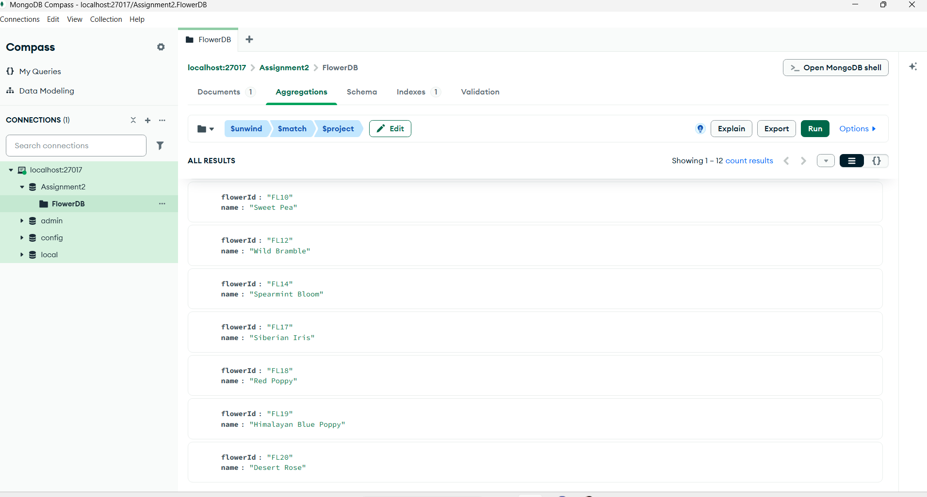
Results:
flowerId : "FL01"
name : "Sun Flare Daisy"
flowerId : "FL02"
name : "Midnight Rose"
flowerId : "FL03"
name : "Tiger Lily"
flowerId : "FL06"
name : "Lavender Mist"
flowerId : "FL07"
name : "Golden Buttercup"
flowerId : "FL10"
name : "Sweet Pea"
flowerId : "FL12"
name : "Wild Bramble"
flowerId : "FL14"
name : "Spearmint Bloom"
flowerId : "FL17"
name : "Siberian Iris"
flowerId : "FL18"
name : "Red Poppy"
flowerId : "FL19"
name : "Himalayan Blue Poppy"
flowerId : "FL20"
name : "Desert Rose"
- Customers in the same city as shop locations
Code (Aggregation stages):
Stage1: {$project: { "cust": "$BotanicalConsortium.Customers.Customer", "shopCities": "$BotanicalConsortium.Shops.Shop.city" }}
Stage 2: {$unwind: "$cust"}
Stage 3:{$match: { "$expr": { "$in": ["$cust.city", "$shopCities"] } }}
Stage4: {$project: { "name": "$cust.name", "city": "$cust.city", "_id": 0 }}
Screenshot:
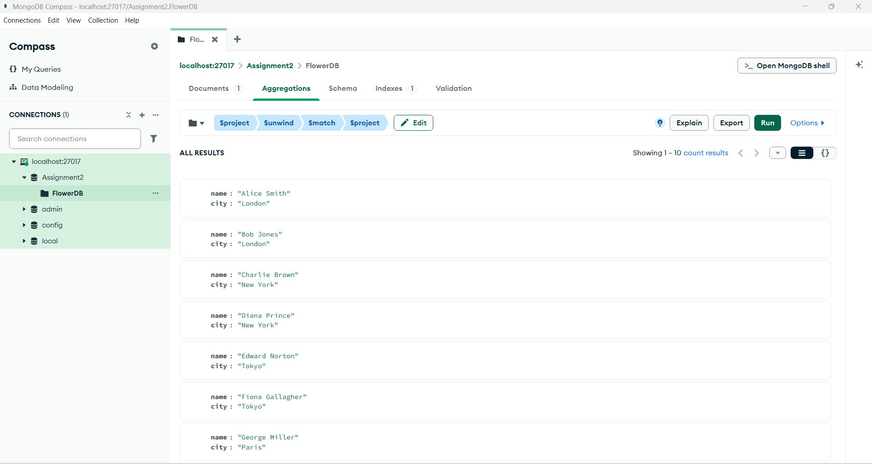
Results:
name: "Alice Smith"
city: "London"
name: "Bob Jones"
city: "London"
name: "Charlie Brown"
city: "New York"
name: "Diana Prince"
city: "New York"
name: "Edward Norton"
city: "Tokyo"
name: "Fiona Gallagher"
city: "Tokyo"
name: "George Miller"
city: "Paris"
name: "Hannah Abbott"
city: "Paris"
name: "Ian Wright"
city: "Sydney"
name: "Julia Roberts"
city: "Sydney"
- Flowers that are never stocked in any shop
Code (Aggregation Stages):
Stage1: {$project: { "allFlowers": "$BotanicalConsortium.Flowers.Flower", "stockedIds": "$BotanicalConsortium.Inventory.Row.flowerId" }}
Stage 2: {$unwind: "$allFlowers"}
Stage 3: {$match: { "$expr": { "$not": { "$in": ["$allFlowers.flowerId", "$stockedIds"] } } }}
Stage 4: {$project: { "flowerId": "$allFlowers.flowerId", "name": "$allFlowers.name", "_id": 0 }}
Screenshot:
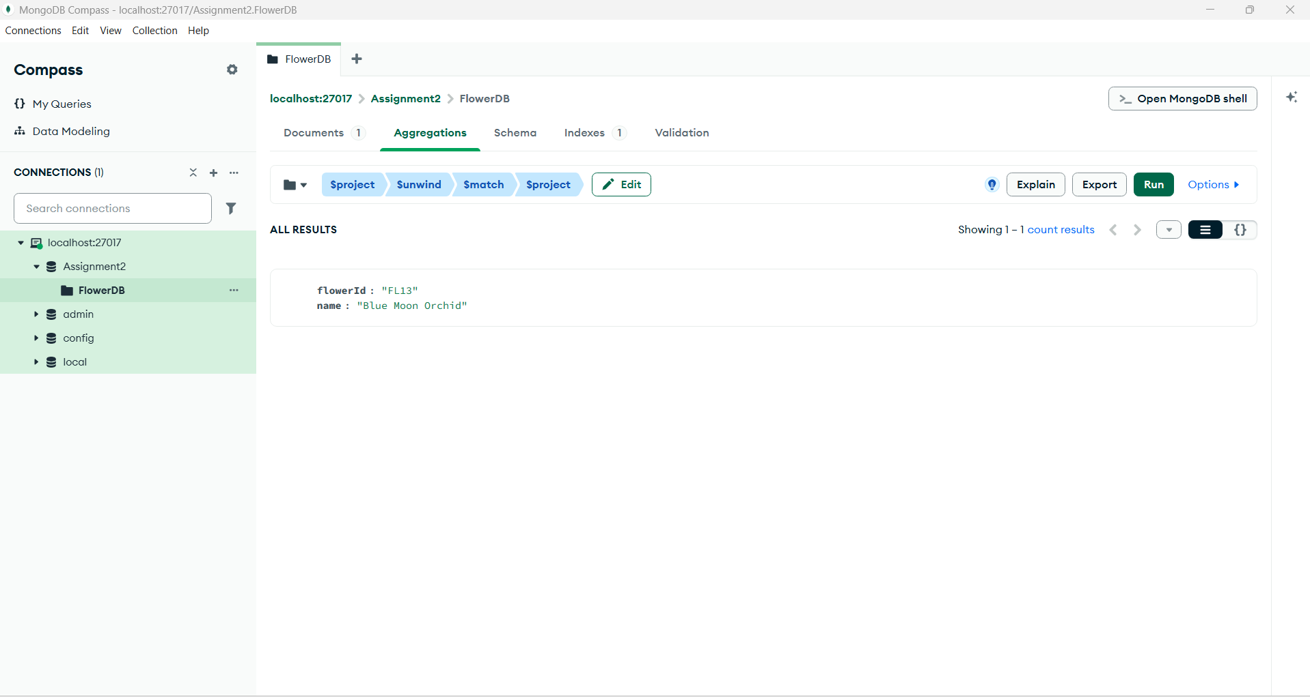
Results:
flowerId: "FL13"
name: "Blue Moon Orchid"

Aggregation/ Grouping:
- Flowers that bloom in spring but are not in the Asteracea family
Code( Aggregation Stages):
Stage 1: { $unwind: "$BotanicalConsortium.Flowers.Flower" },
Stage 2: { $match: { "BotanicalConsortium.Flowers.Flower.seasons": { $regex: /Spring/ }, "BotanicalConsortium.Flowers.Flower.familyId": { "$ne": "FAM01" }}},
Stage 3: {$project: {"name": "$BotanicalConsortium.Flowers.Flower.name", "familyId": "$BotanicalConsortium.Flowers.Flower.familyId", "_id": 0 }}
Screenshot:
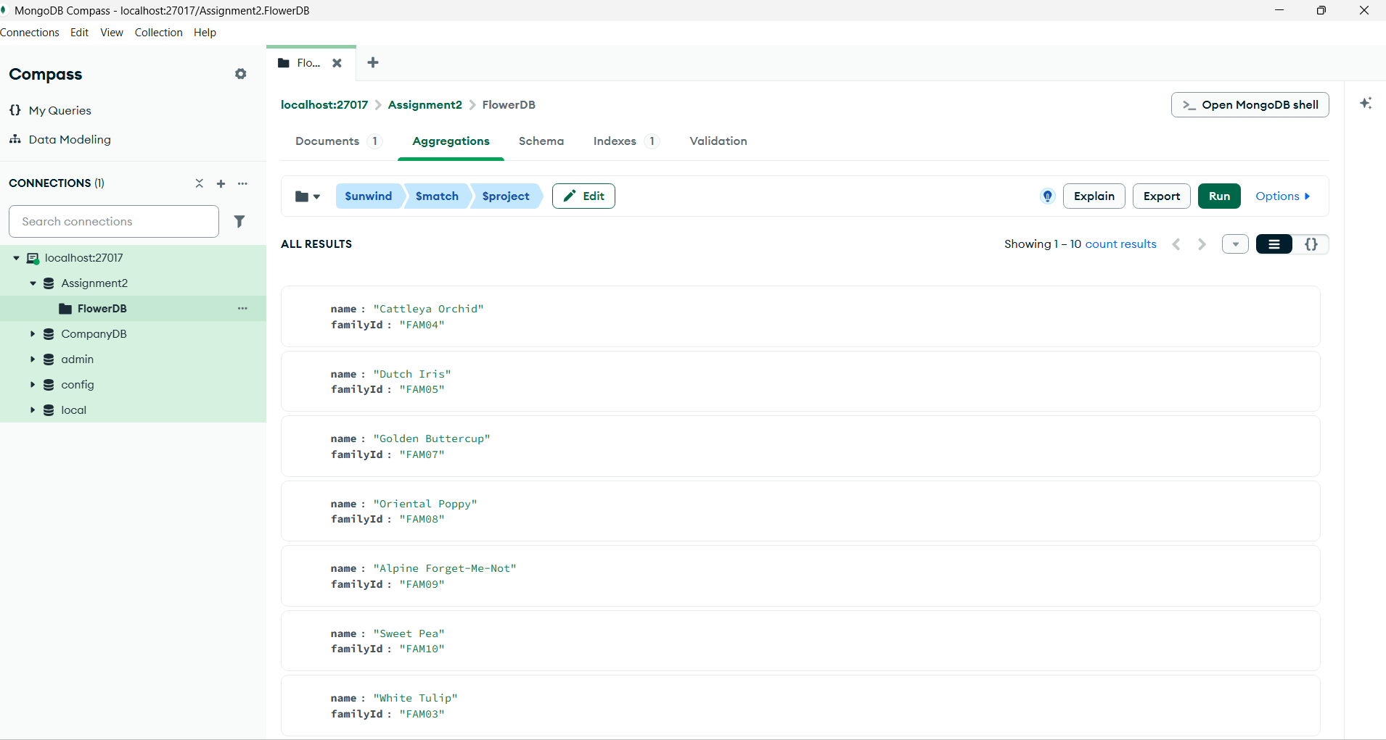
Results:
name: "Cattleya Orchid", familyId : "FAM04"
name : "Dutch Iris", familyId: "FAM05"
name : "Golden Buttercup", familyId: "FAM07"
name : "Oriental Poppy", familyId: "FAM08"
name : "Alpine Forget-Me-Not", familyId: "FAM09"
name : "Sweet Pea", familyId: "FAM10"
name : "White Tulip", familyId: "FAM03"
name : "Anemone", familyId: "FAM07"
name : "Siberian Iris", familyId: "FAM05"
name : "Desert Rose", familyId: "FAM02"
- For each family, show its name and the total stock quantity across all shops.
Code (Aggregation Stages):
Stage 1: { $unwind: "$BotanicalConsortium.Inventory.Row" }
Stage 2 : { $lookup: from: "FlowerDB", let: { flower_id: "$BotanicalConsortium.Inventory.Row.flowerId"}, pipeline: [ { $unwind: "$BotanicalConsortium.Flowers.Flower"}, {$match: {$expr: {$eq: [ "$BotanicalConsortium.Flowers.Flower.flowerId", "$$flower_id" ] } } }, {$replaceRoot: {newRoot: "$BotanicalConsortium.Flowers.Flower"} } ],as: "flower_details"}
Stage 3 : { $unwind: "$flower_details" }
Stage 4 : { $lookup: from: "FlowerDB", let: { family_id: "$flower_details.familyId" }, pipeline: [ { $unwind: "$BotanicalConsortium.Families.Family" }, { $match: { $expr: { $eq: [ "$BotanicalConsortium.Families.Family.familyId", "$$family_id" ] } } }, { $replaceRoot: { newRoot: "$BotanicalConsortium.Families.Family" } } ], as: "family_details"}
Stage 5 : { $unwind:"$family_details"}
Stage 6 : { $group: { _id: "$family_details.familyName",
subtotal: { $sum: { $toInt: "$BotanicalConsortium.Inventory.Row.stock"} } } }
Stage 7 : { $project: { _id: 0, flowerFamily: "$_id", subtotal: 1} }
Stage 8 : {$sort:{ subtotal: -1}}
Screenshot:
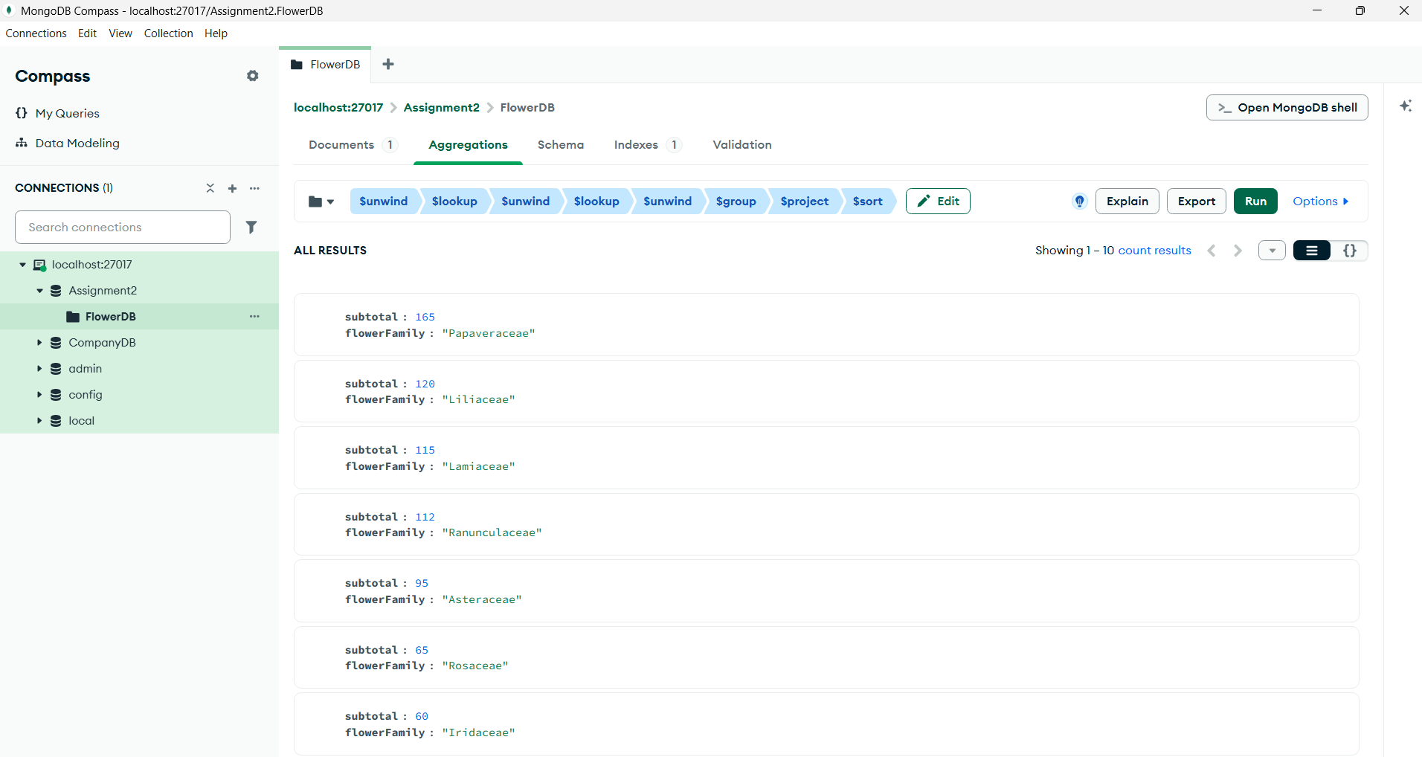
Results:
subtotal : 165, flowerFamily : "Papaveraceae"
subtotal : 120, flowerFamily : "Liliaceae"
subtotal : 115, flowerFamily : "Lamiaceae"
subtotal : 112, flowerFamily : "Ranunculaceae"
subtotal : 95, flowerFamily : "Asteraceae"
subtotal : 65, flowerFamily : "Rosaceae"
subtotal : 60, flowerFamily : "Iridaceae"
subtotal : 35, flowerFamily : "Fabaceae"
subtotal : 15, flowerFamily : "Boraginaceae"
subtotal : 10, flowerFamily : "Orchidaceae"

JSON Modeling Optimization performance choice:
For my JSON model I used Referencing, having Ids to keep the file concise. To look up the flower family each flower makes a reference to that table rather than each flower in the same family having the flower family description within it. This keeps the file much smaller by avoiding redundancy, and also allows for quick updates by changing only one description rather than updating every flower independently. To see the flower and flower description the team does have to use Join within MongoDB.

